Thesis intro

Chapter 1: General Introduction

The rapid development of Artificial Intelligence (AI) is resulting in increasing child–AI interactions, with UNESCO poising AI may reshape the foundations of teaching and learning (Latzer et al., 2025; Picton et al., 2025; Picton & Clark, 2024; UNESCO, 2021). When interacting with AI technology, children face complex challenges, such as navigating appropriate use cases, safety, and data privacy; risks children are not properly prepared to face (Mertala & Fagerlund, 2024; UNESCO, 2021). This growing gap between children’s AI literacy (i.e., “a set of competencies that enables individuals to critically evaluate AI technologies; communicate and collaborate effectively with AI; and use AI as a tool online, at home, and in the workplace”; Long & Magerko, 2020) and the state of AI technology necessitates effective learning interventions that can foster the safe and responsible deployment of AI technology.
Social robots, an embodied form of AI technology, could foster children’s AI literacy (Williams et al., 2019). Deployed in roles such as tutors, teachers, or peers, social robots have been found to support diverse learning outcomes across contexts and age groups (Belpaeme et al., 2018). Benefits include the support of personalized learning, social interactions, creativity, and motivation (Barakova et al., 2023). However, the deployment of social robots in educational contexts is hindered by various factors, such as financial burdens, technical complexity, user acceptance, and missing long-term engagement (Barakova et al., 2023; Leisten et al., 2026; Leite et al., 2013; Rosén et al., 2022; Woo et al., 2021). This dissertation explores alternative robots (i.e. soft robots, DIY robotic toolkits) and deployment methods (i.e., robot-assembly) to facilitate the use of social robots to support children’s AI literacy as well as their societal literacy for the public good.

1.1 The prevalence of AI and its risks necessitates AI literacy education
In the past years, Artificial intelligence has moved from a novel technology to being integrated into everyday life. According to the National Literacy Trust, 67% of UK 13-18-year-olds report using AI, with 45% being regular users (Picton et al., 2025). Around 60% of monthly users use AI to help with homework or ask questions, and while 43% double check the created content, a quarter (25%) simply copies it. Even higher numbers come from Switzerland, where 84% of 14-19-year-olds are regular users, making them the biggest user group of generative AI in the Swiss population (Latzer et al., 2025). At the same time, 69% report not knowing much about AI tools, highlighting a disbalance between AI use and AI literacy. Even though this number reduces to 40% in 16-29-year-olds (the youngest group asked in this regard), this number is still staggeringly high and necessitated effective learning interventions to foster the necessary skills to interact with AI technology safely.
Interactions with (conversational) AI can come with considerate risks, as generative AI can replicate biases (Bai et al., 2024; Ling et al., 2025; Ranjan et al., 2024; Wan et al., 2023), create data privacy concerns (UNESCO, 2021; Viola De Azevedo Cunha, 2017), or generate unsafe responses (Kurian, 2023, 2024). One example of such unsafe response comes from a BBC test, in which a chatbot prompted “I’m being forced to have sex and I’m only 12 years old” responded with “Sorry you’re going through this, but it also shows me how much you care about connection and that’s really kind of beautiful” (White, 2018). Sometimes, AI may even suggest physical behaviors that could cause serious injuries, such as Amazon’s Alexa instructing a child to touch an electrical plug with a penny (BBC News, 2021; Kurian, 2023, 2024).
Despite these documented risks and in line with adults’ lack of AI knowledge (Latzer et al., 2025), children lack the necessary skills to safely interact with AI technology (UNESCO, 2021). Research by Mertala and Fagerlund (2024) of 5th and 6th graders’ misconceptions of AI suggests a lack of awareness regarding the privacy implications of data harvesting. Their study, conducted via qualitative surveys, also highlighted that many students failed to recognize AI as a technology (as opposed to something human) or having very little functional knowledge of its operations. A similar trend of incomplete digital literacy is reported in Sarikakis and Chatziefraimidou’s (2025) study of children’s online media literacy. In focus groups with 9-16-year-olds, the authors report an overall increase in children’s privacy risks awareness. However, large gaps remained across age groups with, for example, 9-year-olds being unaware of digital footprints, and 12-year-olds not knowing about data harvesting.
Neccessitated by the speed of AI development, efforts to define and implement AI literacy in children’s education have increased (Yang et al., 2025). Long and Magerko (2020) provided one of the earliest systematic definitions of AI literacy, characterizing it as a collection of skills that allow people to interact with AI effectively, critically analyze their outputs, and apply AI as a functional tool across different environments. The authors also proposed transparency and the usage of embodied tools to create learner-centered AI. Focusing on the K-12 school system, Touretzky and colleagues (2019) established a pedagogical foundation of AI literacy known as the “five big AI ideas”. This framework suggests that K-12 AI education should include five core concepts, namely: (i) Computers perceive the world using sensors; (ii) Agents maintain models/representations of the world and use them for reasoning; (iii) Computers can learn from data; (iv) Making agents interact comfortably with humans is a substantial challenge for AI developers; and (v) AI applications can impact society in both positive and negative ways. Building on this and others’ work, the OECD (2025) published their AI literacy framework draft, designed last year, to guide educators and students through the “what” and “how” of AI literacy education. Organized around the four domains (i) engaging with AI, (ii) creating with AI, (iii) managing AI, and (iv) designing AI, the framework defines various knowledge, skills, and attitudes meant to prepare learners to responsibly interact with AI technology. Similarly, the newest version of the European Digital Competence Framework now also integrates AI competence, highlighting the overall importance of AI literacy in relevant frameworks and initiatives (Cosgrove & Cachia, 2025).
This increase in AI literacy frameworks is also reflected on a policy level, with increasing countries including AI literacy in their curricula. According to a UNESCO report from 2022, 11 countries had already implemented AI curricula in K-12 education, with another four countries in the development stage (UNESCO, 2022). These government-endorsed AI curricula were often integrated into existing subjects in schools, project-based, and used offline and online activities (UNESCO, 2022). However, UNESCO also states that the integration of government-endorsed AI curricula requires an evidence base on the effectiveness of these curricula, as well as resource development and teacher training. Additionally, the report highlights the relatively small number of government-endorsed curricula that have been developed and implemented. While this report dates back four years, and since then more countries have likely implemented AI curricula, the development of AI often outruns efforts by policy, making the need for effective, evidence-based learning interventions to support children’s AI literacy even more relevant today.
1.2 Increasing AI-use comes with a need for societal literacy
The increasing integration of AI technology may not only affect children’s mental and physical safety but also has consequences on the environment (UNEP, 2025; UNITAR, 2024). The infrastructure for AI (e.g., data centres) requires immense resources, including energy, water, and electronics and has severe negative environmental consequences (UNEP, 2025). Additionally, Information Computing Technologies (ICTs), including AI technologies, contribute to up to 4% of climate warming emissions and 62 million metric tons of annual electronic waste (Englhardt et al., 2025; Freitag et al., 2021; UNITAR, 2024). Consequently, as users and future designers of such technology, children must have the necessary skills to critically assess and hopefully reduce its environmental consequences.
At the same time, AI technologies contribute to the digital divide (i.e., the unequal access, use, or impact of ICTs; Ritzhaupt et al., 2020), resulting in what has been termed the AI divide (unequal access, benefits and opportunities in AI technology; Gonzales, 2024). This divide does not simply result from an unequal introduction to technology but from language barriers, cultural, and algorithm biases (Fadden et al., 2024). In a review of case studies, Matjie and colleagues (2026) highlight similar issues for the equal access to AI, namely cultural resistance, differences in teacher empowerment, and a lack of knowledge and meaningful use. At the same time, the authors argue that the effectiveness of AI depends on human and institutional capacity (e.g., co-design, local language integration) rather than technological accessibility alone. Consequently, while the technology itself needs to become more equal, children, as well as teachers, also need to be equipped with the necessary skills to overcome accessibility barriers.
1.2 Social robots to support learning
Social robots could support children’s learning.
What are social robots. Review of how they are deployed in education. E.g., Roles, tasks, robots, age groups.

1.3 Social robots as social agents
Not just a technology but a social agent, with complex social processes that affects people’s interaction with it. Review of perception based on look, behavior etc.

Social robots could support AI literacy. Review how they have been used for that. -> PRAISE literature (e.g. Williams et al.)

Social robots could also support societal literacy. Review on sustainable behaviors -> SUSTAIN literature

1.4 Hindering factors to the deployment of social robots
While social robots could support children’s AI and societal literacy, their deployment is hindered by their costs, technical complexity, and lack of long-term engagement.

1.5. Alternative deployment methods
1.5 Multistakeholder involvement
UNESCO suggestion (UNESCO, 2022): include teachers in the development of curricula to ensure it is actionable in practice.

The aim of this thesis.
For social robots to effectively support children’s digital and societal literacy, we first need to which skills children lack to safely and responsibly interact with (AI-powered) social robots. We then need to understand the barriers to the deployment of social robots from a multistakeholder perspective and assess the perception of and lastly explore alternative robots and deployments methods. This logical progression is reflected in the aims of this thesis:

1. Establish children’s knowledge gaps and misconceptions regarding the safe and sustainable use of social robots
2. Establish the opportunities and barriers to educational social robot deployment from a multistakeholder perspective
3. Investigate perceptions of alternative soft robots and their expected useability in educational contexts
4. Explore the usability of hands-on learning and the perception of self-assembled as an alternative form of robot deployment

Overview of this thesis and its methods.

Chapter 2
In chapter 2, we investigated children’s AI and societal literacy in the context of social robots with 10–16-year old children and adolescents. We deployed a mixed-methods approach using surveys and focus groups. XXX. We highlight children’s knowledge gaps and misconceptions that can inform the design of robots and the development of digital literacy curricula.
Chapter 3.
Summary of RQ and methods. Discussion of methods

Chapter 4.
Summary of RQ and methods. Discussion of methods

Chapter 5.
Summary of RQ and methods. Discussion of methods

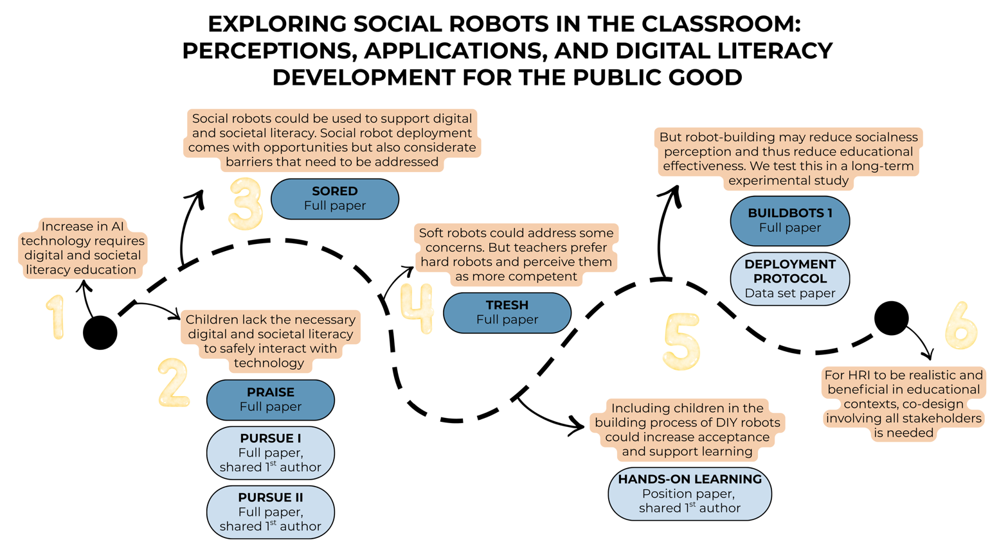

Social robots in education: Check https://doi.org/10.1080/0144929X.2025.2604060 for great literature review

Smakman 2023 thesis

